Mars Australia
&
New Zealand

MFANZ Plant Database Environment

Support & Operation

Table of Contents

Modification History 3
1 Document Assumptions / Notes 3
2 Environment Overview 4
2.1 Individual Plant Tier Details 4
3 WAN Environment Diagram 5
4 System Support Overview 6
4.1 Support Flow 6
4.2 Change Management 6
4.3 Incident Management 7
4.4 Support Process 7
4.4.1 Reprocess Recipe Conversion 7
4.4.2 Update Teco Status 7
5 Interfaces: LADS to Plant Databases (LADPDB) 8
5.1 Overview 8
5.2 LADPDB01 : Process Orders 8
5.3 LADPDB02 : Material Data 8
5.4 LADPDB03 : Customer Address 8
5.5 LADPDB04 : BOM Detail 9
5.6 LADPDB05 : BOM Alternative 9
5.7 LADPDB06 : Production Resources 9
5.8 LADPDB07 : Reference Characteristics 9
5.9 LADPDB08 : Reference Data 9
5.10 LADPDB09 : Reference Purchasing Source 10
5.11 LADPDB10 : Customer Sales Area 10
5.12 LADPDB11 : Material Classifications 10
5.13 LADPDB12 : Vendor Company 10
5.14 LADPDB13 : Material BOM 10
5.15 LADPDB14 : Stock Balance 11
5.16 LADPDB15 : In Transit 11
5.17 LADPDB16 : Characteristic Values 11
6 Supported Applications 12
6.1 Overview 12
6.1.1 Factory Process 12
6.2 Electronic Trace (eTrace) 13
6.3 Pallet Tagging / Pallet Tickets / Pallet Tagging V2 13
6.4 Electronic Recipe (eRecipe) / Factory Recipe Report (FRR) 13
6.5 Re-Timing Tool (RTT) 13
6.6 Teco Tool 13
6.7 Automation 14
6.8 Batching In 14
6.9 MVMS 14
7 Database Access 14

Modification History

Date | Version | Description | Author
20th June, 2008 | 1.0 | Original - DRAFT | Trevor Keon

Document Assumptions / Notes

- The reader is assumed to have an understanding (or access to the documentation) relating to ICS/LADS functionality and operation.

- This document is intended for AP GSM Information Delivery Analysts who will be providing third level support.

- This document is focused primarily on the operational environment for the MFANZ plant databases – therefore, it does not cover extensive details on Global or Regional systems such as SAP(R/3), Tolas, ICS/LADS, etc.

Environment Overview

Individual Plant Tier Details

Site | Tier | Host | Database | Data/Script Path | Queue Manager
Ballarat (MCA) | Production | MCALX001 | DB0719P | /ics/prod/ … | QM0075P
Ballarat (MCA) | Test | MCALX002 | AP0126D | /ics/test/ … | QM0077T
Scoresby (SCO) | Production | SCOLX001 | DB0720P | /ics/prod/ … | QM0074P
Scoresby (SCO) | Test | SCOLX002 | AP0132D | /ics/test/ … | QM0076T
Wyong (MFA) | Production | MFALX001 | MFA005 | /ics/prod/ … | QM0056P
Wyong (MFA) | Test | MFALX002 | MFA002 | /ics/test/ … | QM0055T
Wanganui (WGI) | Production | WGILX001 | AP0065P | /ics/prod/ … | QM0150P
Wanganui (WGI) | Test | WGILX001 | AP0068T | /ics/test/ … | QM0151T
Wodonga (WOD) | Production | WODLX001 | WOD013 | /ics/prod/ … | APQM006P
Wodonga (WOD) | Test | APLX001 | WOD023 | /ics/test/ … | APQM003T
Bathurst (BTH) | Production | BTHLX001 | BTH001 | /ics/prod/ … | APQM005P
Bathurst (BTH) | Test | BTHLX002 | BTH005 | /ics/test/ … | APQM004T
Note: no specific development environments exist for any of the plant databases

Relevant Database Users and Descriptions

Database User | Overview / Access / Rights
PLANT_SUPPORT | - Doesn’t own any objects  - Used as generic login for site team to query data across all schemas supported by AP GSM Information Delivery Team
BDS & BDS_APP | - Stands for Business Data Store  - Stores only data received from MFANZ LADS environment  - Hosts packages to load the data from ICS and store in the BDS tables
MANU & MANU_APP | - Contains information related to the manufacturing side of the factory  - Hosts packages to modify recipe information and alter production schedule
PT & PT_APP | - Contains information related to pallet tagging  - Hosts packages to generate various pallet tagging information, such as goods receipt, actual consumption, etc

WAN Environment Diagram

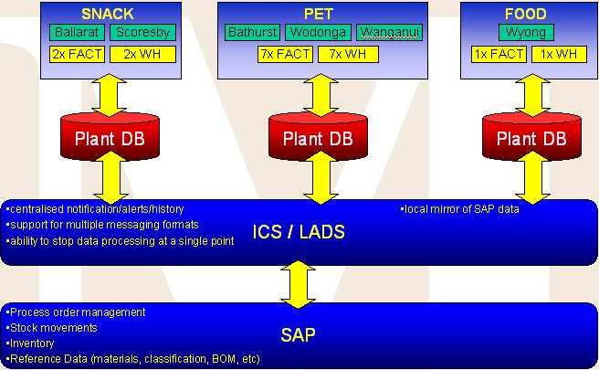

System Support Overview

Support Flow
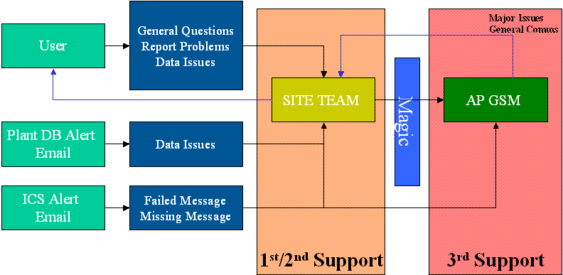

Change Management
Application changes will be managed by the team who has ownership of the application, although, the actual development effort may be completed by either the relevant Site Team or AP GSM Information Delivery team. Regardless of who manages and develops changes, standard Mars IS Change Control process must be adhered to. This is as follows:

- The Magic system is used to manage all Change Control tickets.
- A valid & fully approved Change Control must be in place before any changes to a production environment are made.
- An AP GSM Information Delivery manager must be one of the approvers (Linden Glen) and the relevant site team primary contact (see table below).
- It is advisable, that any changes made be discussed and agreed with AP GSM Information Delivery prior to commencement to save time & additional effort when ready to migrate to Production.

Site Team contact details

Site | Primary Contact | Backup Approver
Ballarat | Liam Watson | Jodie Irvine
Scoresby | Liam Watson | Jodie Irvine
Wyong | Ricardo Carneiro | Garry Shields
Wanganui | Beau Frericks | Bryce Gosnell
Wodonga | Daniel Owen | Jason Knight
Bathurst | Matt Bourke | Jason Knight

Incident Management
The relevant Site Team will be the primary point of contact for any applications related issues experienced by End Users/Functional Experts. In the event the Site Team needs to esculate to AP GSM Information Delivery this should be done via a Magic Incident and assigned to the group DW_INFO_DELIVERY_AP. Support effort cannot commence until a valid Incident has been raised and assigned. Refer to 4.1 Support Flow.
*Note: Incidents may be prioritised based on other support requirements within the region.

Support Process
A support folder has been created in the Tortoise SVN repository (SOURCE\PDB\SUPPORT). This folder contains scripts to aid in resolving any known support issues. All scripts created in future to resolve an issue should be added to this folder, and an entry included in this documentation detailing the symptom and actions.

Reprocess Recipe Conversion
When a recipe is loaded into BDS, a recipe conversion package is run to convert a given process order into a set of records that can easily be used by an application to print FRR’s (Factory Recipe Reports). This is required to be run on all process orders that are sent to the plants.

Symptom | Resolution | File | Parameters | Schema
Process order failed to run recipe conversion | Manually run recipe conversion for the affected process order(s) | redo_recipe_conversion.sql | Process order | MANU_APP

Update Teco Status
When a process order has been completed, SAP will send an update to set the process order teco status (technically completed) to ‘YES’. Once that is done, the process order cannot be opened in the factory. There are cases when SAP does not send the teco status down, which can result in a completed process order being reopened. The process order must have its teco status manually set to ‘YES’ to avoid any issues in the factory.

Symptom | Resolution | File | Parameters | Schema
Teco status not sent from SAP | Manually update the teco status to ‘YES’ for the process order | update_teco_status.sql | Process order  Plant code | BDS_APP

Interfaces: LADS to Plant Databases (LADPDB)

Overview
This set of interfaces provides necessary Atlas reference and transactional data for running the factory and related systems. Data is fed live from Atlas to LADS, flattened into BDS, and then sent to the plant database in real-time or batched, depending on the interface. Specifically, the target schema for these interfaces is BDS (Business Data Store).

The transfer mechanism used is MQFT over MQSeries technology.

Source code for these interfaces (both source and destination) are owned and managed by the central AP GSM Information Delivery team and are available in the SVN repository (SOURCE\PDB\BASE).

LADPDB01 : Process Orders

Interface ID | LADPDB01
Extract Procedure | plant_process_order_extract
Data Filters | -
Activation | Real-time
Atlas Interface | ATLLAD01
Target Table(s) | BDS.BDS_RECIPE_HEADER  BDS.BDS_RECIPE_BOM  BDS.BDS_RECIPE_RESOURCE  BDS.BDS_RECIPE_SRC_TEXT  BDS.BDS_RECIPE_SRC_VALUE
Interface Content | Contains control recipe information for a given process order. Gives the plant information about what to make, how to make it, when to make it, and so on.

LADPDB02 : Material Data

Interface ID | LADPDB02
Extract Procedure | plant_material_extract
Data Filters | MATERIAL_TYPE IN ('ROH', 'VERP', 'NLAG', 'PIPE', 'FERT')  PLANT_CODE LIKE ‘AU%’ or ‘NZ%’  PKG_INSTR_TABLE_USAGE = 'P'  PKG_INSTR_APPLICATION = 'PO'  PKG_INSTR_TYPE = 'Z001'  PKG_INSTR_TABLE = '505'  SALES_ORGANISATION IN ('147', '149')  ITEM_CTGRY IN ('I')
Activation | ladpdb04_schedule – every 30 minutes
Atlas Interface | ATLLAD04
Target Table(s) | BDS.BDS_MATERIAL_PLANT_MFANZ  BDS.BDSMATERIAL_PKG_INSTR_DET  BDS.BDS_MATERIAL_UOM
Interface Content | Contains material information such as UOM (Unit of Measure) and packaging details.

LADPDB03 : Customer Address

Interface ID | LADPDB03
Extract Procedure | plant_cust_address_extract
Data Filters | ADDRESS_TYPE = 'KNA1'
Activation | ladpdb03_schedule – every 30 minutes
Atlas Interface | ATLLAD15
Target Table(s) | BDS.BDS_ADDR_CUSTOMER_DET
Interface Content | Contains address details for each customer in MFANZ

LADPDB04 : BOM Detail

Interface ID | LADPDB04
Extract Procedure | plant_bom_det_extract
Data Filters | -
Activation | ladpdb04_schedule – every 30 minutes
Atlas Interface | ATLLAD17
Target Table(s) | BDS.BDS_BOM_DET
Interface Content | Contains Bill of Material information for the factory.

LADPDB05 : BOM Alternative

Interface ID | LADPDB05
Extract Procedure | plant_bom_alternative_extract
Data Filters | -
Activation | Real-time
Atlas Interface | ATLLAD10
Target Table(s) | BDS.BDS_REFRNC_HDR_ALTRNT
Interface Content | Contains alterative Bill Of Material information for the factory. Sent in real-time as the reference data from ATLLAD10 cannot be filtered to a specific piece of information.

LADPDB06 : Production Resources

Interface ID | LADPDB06
Extract Procedure | plant_prodctn_resrc_extract
Data Filters | -
Activation | Real-time
Atlas Interface | ATLLAD10
Target Table(s) | BDS.BDS_PRODCTN_RESRC_EN
Interface Content | Contains production resource information and the plant it is located at. Sent in real-time as the reference data from ATLLAD10 cannot be filtered to a specific piece of information.

LADPDB07 : Reference Characteristics

Interface ID | LADPDB07
Extract Procedure | plant_refrnc_charistic_extract
Data Filters | -
Activation | Real-time
Atlas Interface | ATLLAD10
Target Table(s) | BDS.BDS_REFRNC_CHARISTIC
Interface Content | Contains reference characteristic data. Sent in real-time as the reference data from ATLLAD10 cannot be filtered to a specific piece of information.

LADPDB08 : Reference Data

Interface ID | LADPDB08
Extract Procedure | plant_refrnc_plant_extract
Data Filters | -
Activation | Real-time
Atlas Interface | ATLLAD10
Target Table(s) | BDS.BDS_REFRNC_PLANT
Interface Content | Contains plant information, such as address details and plant code. Sent in real-time as the reference data from ATLLAD10 cannot be filtered to a specific piece of information.

LADPDB09 : Reference Purchasing Source

Interface ID | LADPDB09
Extract Procedure | plant_refrnc_prch_src_extract
Data Filters | -
Activation | Real-time
Atlas Interface | ATLLAD10
Target Table(s) | BDS.BDS_REFRNC_PURCHASING_SRC
Interface Content | Contains details of the purchasing source of materials. Sent in real-time as the reference data from ATLLAD10 cannot be filtered to a specific piece of information.

LADPDB10 : Customer Sales Area

Interface ID | LADPDB10
Extract Procedure | plant_cust_sales_area_extract
Data Filters | -
Activation | ladpdb10_schedule – every 30 minutes
Atlas Interface | ATLLAD11
Target Table(s) | BDS.BDS_CUST_SALES_AREA
Interface Content | Contains details on a customer in regard to the sales organisation they use, the distribution channel, division, and so on.

LADPDB11 : Material Classifications

Interface ID | LADPDB11
Extract Procedure | plant_material_classfctn_extract
Data Filters | -
Activation | ladpdb11_schedule – every 30 minutes
Atlas Interface | ATLLAD06
Target Table(s) | BDS.BDS_MATERIAL_CLASSFCTN
Interface Content | Contains classification information for materials used by all plants.

LADPDB12 : Vendor Company

Interface ID | LADPDB12
Extract Procedure | plant_vendor_comp_extract
Data Filters | -
Activation | ladpdb12_schedule – every 30 minutes
Atlas Interface | ATLLAD19
Target Table(s) | BDS.BDS_VEND_COMP
Interface Content | Contains vendor information related to materials used by all plants.

LADPDB13 : Material BOM

Interface ID | LADPDB13
Extract Procedure | plant_material_bom_extract
Data Filters | -
Activation | ladpdb13_schedule – every 30 minutes
Atlas Interface | ATLLAD08
Target Table(s) | BDS.BDS_MATERIAL_BOM_HDR  BDS.BDS_MATERIAL_BOM_DET
Interface Content | Contains BOM information for a specific material used by all plants.

LADPDB14 : Stock Balance

Interface ID | LADPDB14
Extract Procedure | plant_stock_extract
Data Filters | -
Activation | Real-time
Atlas Interface | ATLLAD02
Target Table(s) | BDS.BDS_STOCK_HEADER  BDS.BDS_STOCK_DETAIL
Interface Content | Contains stock balance information of raw materials used during manufacturing. This information allows the plant to know the total amount of a given raw material so they can plan for the schedule ahead.

LADPDB15 : In Transit

Interface ID | LADPDB15
Extract Procedure | plant_intransit_extract
Data Filters | -
Activation | Real-time
Atlas Interface | ATLLAD23
Target Table(s) | BDS.BDS_INTRANSIT_HEADER  BDS.BDS_INTRANSIT_DETAIL
Interface Content | Contains in transit figures for raw materials used during manufacturing. Once the raw materials arrive they will be added to the stock balance and removed from the in transit figures.

LADPDB16 : Characteristic Values

Interface ID | LADPDB16
Extract Procedure | plant_charistic_value_extract
Data Filters | -
Activation | ladpdb16_schedule – every 30 minutes
Atlas Interface | ATLLAD21
Target Table(s) | BDS.BDS_CHARISTIC_VALUE_EN
Interface Content | Contains characteristic values for the plants.

Supported Applications

Overview
The following applications are contained within the schemas our team currently supports, being MANU, PT, BDS and the associated APP schemas:

Application | Description | Schema | Sites
eTrace | Electronic Trace | PT | MCA, SCO
Pallet Tickets |  | PT | MCA, SCO
Pallet Tagging |  | PT | MCA, SCO, WGI, WOD, BTH
eRecipe | Electronic Recipe | MANU | MCA, SCO, MFA
FRR | Factory Recipe Report | MANU | MCA, SCO, MFA, WOD, BTH
RTT | Re-Timing Tool | MANU | MCA, SCO, MFA, WOD, BTH
Teco Tool |  | BDS | MCA, SCO
Pallet Tagging V2 |  | PT | MFA
Automation |  | MANU | MFA
Batching In |  | MANU | MFA
MVMS | ??? | MANU | WGI

Factory Process

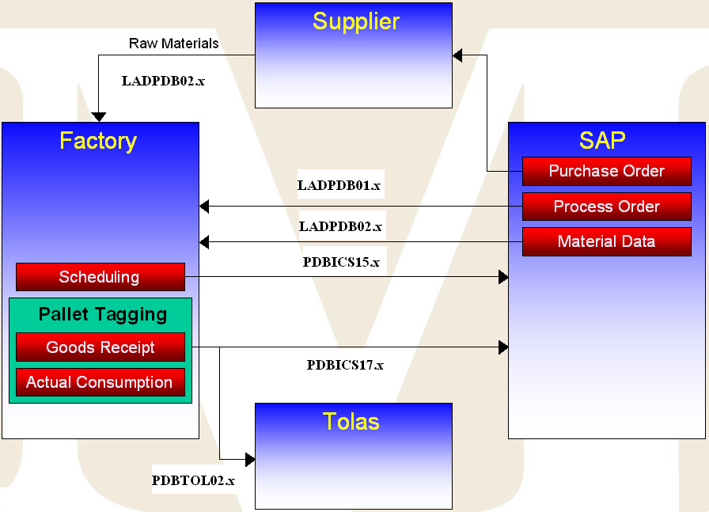

Purchase Orders
- Forecasting defines how much product to make
- Order raw materials from suppliers for the plants to manufacture a product
- Suppliers deliver the raw materials before the date of the process order

Process Orders / Control Recipes
- Process orders are a commitment to make a specific amount of product
- Defines what to make, when to make it, where to make it and what materials to use
- Bill of materials (BOMs) define a hierarchy of materials needed to produce a product
- Process orders use a snapshot of BOMs. Does not reference BOMs directly.
- Control recipes define the process instructions. Used by citect/shiftlog to define the settings within the factory for the process order. Simply put, it defines how to make the product.

Material Data
- Contains information on materials used by the factory

Scheduling
- Can be modified by the re-timing tool (RTT). Only used in Bathurst.

Pallet Tagging
- Unique reference to a finished product
- Goods receipt and actual consumption set the stock balance in SAP for the factory. Depends upon the BOM.
- SAP uses pallet tagging information to keep track of what is has made
- Pallet information is also sent to Tolas (warehouse management system)

Electronic Trace (eTrace)
The electronic trace application displays the process order and material for a given pallet number. The Oracle package returns the required information to display in the eTrace web application.

Pallet Tagging / Pallet Tickets / Pallet Tagging V2
Pallet tagging is a method of tracking any given pallet from the factory to the warehouse. The pallet tagging application allows the following:

- Create or cancel pallet/consumption
- Create scrap, rework or reclaim
- Send pallet information to Tolas

Electronic Recipe (eRecipe) / Factory Recipe Report (FRR)
The factory recipe report is an SDS delivered C# application for displaying details about any given recipe. The eRecipe application is a web-based version of FRR, which extracts the information from an Oracle package.

Re-Timing Tool (RTT)
The re-timing tool allows for changes to be made to the schedule of existing control recipes. Although this application is available in all sites, only Bathurst currently uses it.

Teco Tool
The teco (technically completed) tool is used to manually set a given process order to be completed. There are a number of bugs in Atlas which can result in the teco status not being set on any given process order, which means the factory can manufacture the incorrect product.

Automation

Batching In

MVMS

Database Access

Refer to the Environment Overview document in the project database for login details for each site.

